Model Explainability
Teaching Notes
A from-scratch guide to explaining a black-box model, both globally and for a single decision, with every technique cross-checked against an independent alternative, grounded in the loan-default model's own verified results.

Contents

1. Why an Accurate Model Isn't Automatically a Usable One
Two earlier case studies built a Gradient Boosting model that predicts loan default with 0.911 AUC, a genuinely strong result. But an ensemble of hundreds of decision trees isn't something a person can read and understand directly, it's a black box: accurate, but opaque. For a lending model specifically, that opacity is a real problem, not just an academic one: regulations in most jurisdictions require a rejected applicant be told why, "the model said so" is not a legally or ethically acceptable answer.
Model explainability is the set of techniques for opening that box, both in general (which features matter, and how) and for one specific decision (why did this applicant, specifically, get this prediction). This note covers both, using the same verification discipline as every other topic in this series: every technique here is checked against an independent alternative before being trusted.

2. Global Explanations: Which Features Matter Overall?
The simplest global explanation comes free with any tree ensemble: built-in, impurity-based feature importance, tracking how much each feature reduced prediction error across every split in every tree. It's fast, but has a known bias: it tends to favor continuous or high-cardinality features, simply because they offer more possible split points, not necessarily because they matter more. Permutation importance avoids that bias entirely: shuffle one feature's values on the held-out test set, breaking its relationship with the target, and measure how much the model's performance drops.
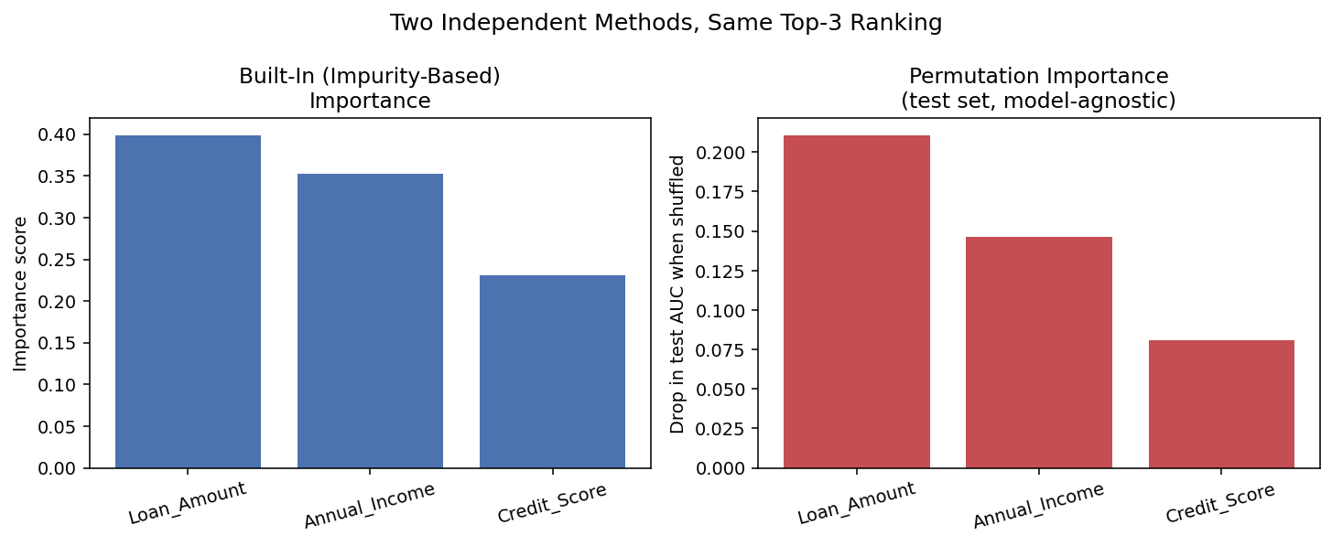
Figure 1. Two completely different methods, built-in impurity-based importance (training-set, tree-internal) and permutation importance (held-out test-set, model-agnostic), independently agree: Loan_Amount, Annual_Income, and Credit_Score dominate, in the same order, with every other feature contributing under 1%.
This agreement matters. If the two methods had disagreed, that would be a signal that the impurity-based ranking might be an artifact of feature type rather than genuine importance. Because they agree here, both can be trusted.

3. Global Explanations: Not Just Which, But How
Knowing Loan_Amount matters doesn't say whether higher amounts increase or decrease risk, or by how much. A Partial Dependence Plot (PDP) answers that directly: sweep one feature across its range, holding every other feature at its real, observed values, and average the model's predicted probability at each point.
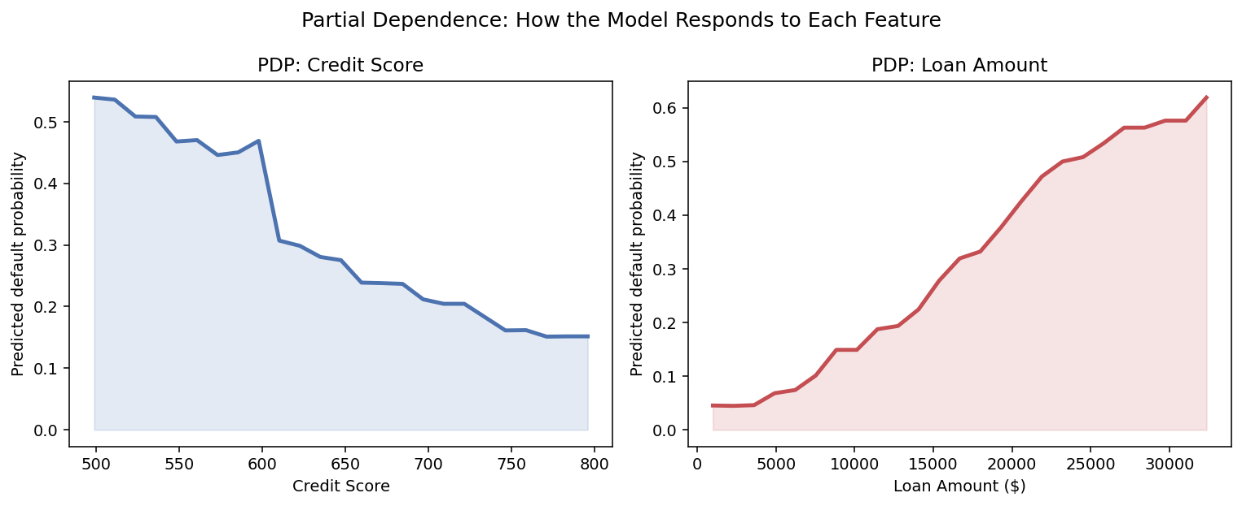
Figure 2. Left: predicted default probability falls steadily as Credit Score rises, from 53.9% at the low end to 15.2% at the high end. Right: predicted default probability rises steadily with Loan Amount, from 4.5% up to 61.9%. Both large, smooth, and exactly the direction a lending officer would expect.
A PDP shows the average effect. That can hide real differences between individuals, an Individual Conditional Expectation (ICE) plot shows the same sweep separately for a sample of actual applicants, with the PDP average overlaid. In the loan model, the individual ICE curves run largely parallel to the PDP average: applicants differ in overall risk level, but nearly everyone's risk responds to Credit_Score in the same direction and at a similar rate, no hidden subgroup reacts the opposite way. That parallel pattern is itself the useful finding: it confirms the PDP average is a fair summary, not one that's masking conflicting behavior between different kinds of applicants.

4. SHAP: Direction and Magnitude, for Every Individual at Once
SHAP (SHapley Additive exPlanations), built on a game-theoretic idea (fairly splitting credit for a prediction among the features that contributed to it), assigns each feature a signed contribution for every individual prediction, not just a single global number. Averaging the size of those contributions across every applicant reproduces a global importance ranking that also carries direction: a summary plot shows each applicant as a dot, colored by that applicant's actual feature value, positioned by how much that feature pushed their specific prediction toward or away from default. On the loan data, this confirms the same story as Figures 1 and 2 from an entirely different angle: high loan amounts push individual predictions toward default, high credit scores push them away, visible applicant by applicant, not just on average.

5. Local Explanations: Why This One Decision?
A rejected applicant doesn't need to know how the model behaves in general, they need to know why their application was flagged. The test applicant the model was most confident would default (99.8% predicted probability, and who did in fact default) makes a concrete example: 31 years old, $14,000 annual income, requesting a $38,757 loan, credit score 517.

LIME: A Simple Local Model, Fit Just Around This Point
LIME (Local Interpretable Model-agnostic Explanations) perturbs the data slightly around this one applicant, observes how the model's prediction shifts, and fits a simple, interpretable linear model to that narrow neighborhood only. It doesn't need to understand the model globally, only well enough right around this one point.

SHAP: An Exact, Guaranteed Decomposition
For this same applicant, SHAP assigns a specific numeric contribution to every feature, and, unlike most explanation methods, these contributions come with a mathematical guarantee: they sum exactly to the model's actual prediction. Base value (the average prediction across all applicants, in log-odds) plus the sum of every feature's SHAP contribution reconstructed this applicant's predicted probability to four decimal places: 0.9979, matching the model's own output exactly.
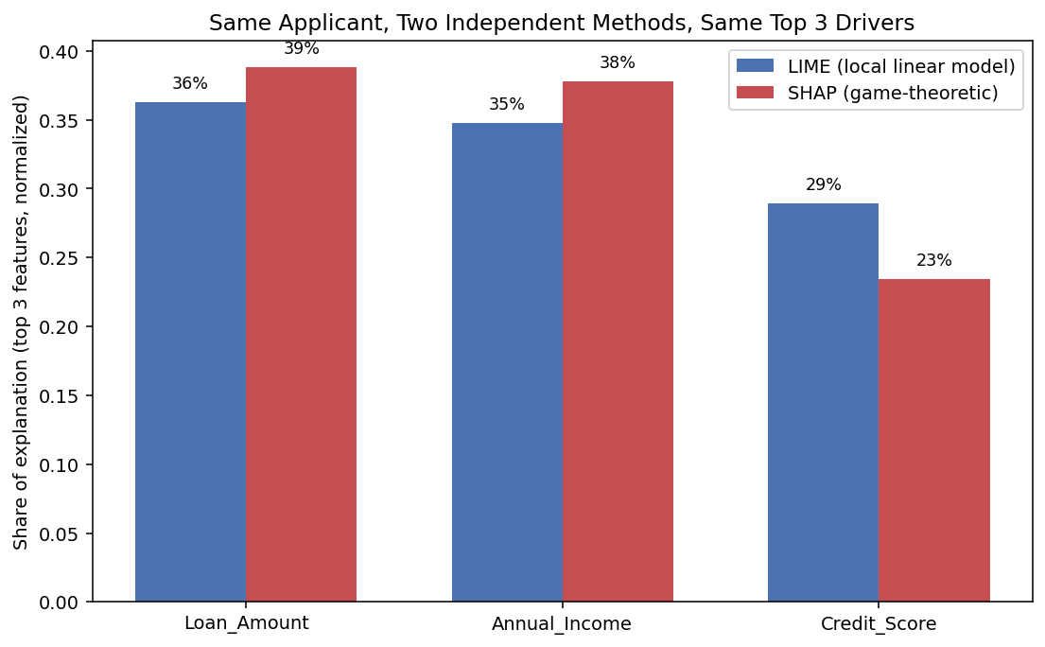
Figure 3. LIME (a local linear approximation) and SHAP (an exact game-theoretic decomposition) independently identify the same top three drivers, in the same order, for the same applicant: Loan_Amount, Annual_Income, then Credit_Score.
Two explanation methods built on entirely different mathematics agreeing on the same top three reasons is real, cross-verified confidence in the explanation. This is the basis for a defensible, automatically-generated adverse-action notice, not a black-box guess dressed up as an explanation.

6. A Caveat: What PDP Assumes, and When It Breaks
PDP's averaging trick, sweep one feature while holding others at their real observed values, has a hidden assumption: that any combination of feature values it evaluates could plausibly occur. When two features are correlated, that assumption fails. Sweeping one feature across its full range while holding a correlated feature fixed can create combinations that never actually happen in reality, and the model, asked to predict on data unlike anything it was trained on, can respond unpredictably.
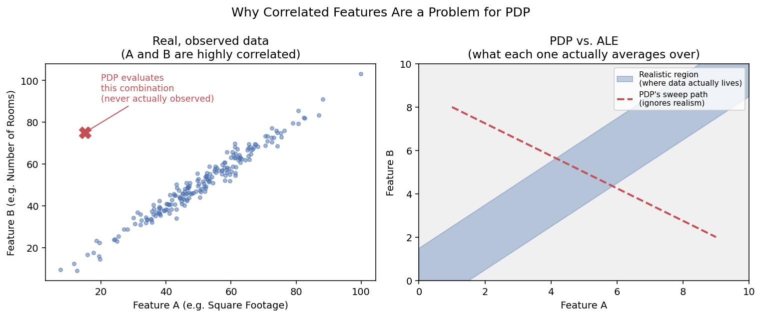
Figure 4. Left: two correlated features, most real data clusters tightly along the diagonal. PDP, in the process of testing one feature's full range, ends up querying combinations (the marked X) far from anywhere real data actually exists. Right: schematically, PDP's sweep path (dashed) cuts straight through unrealistic territory, while the realistic region (shaded) is a narrow diagonal band.
Accumulated Local Effects (ALE) fixes this by only ever averaging within small, local, realistic neighborhoods of the actual data, it never asks the model to extrapolate into combinations that don't occur. On the loan model, Loan_Amount and Annual_Income were verified to be essentially uncorrelated (correlation of −0.005), meaning PDP's assumption isn't violated here, and computing ALE for Loan_Amount confirmed exactly that: the ALE curve rises in the same direction and shape as the PDP curve in Figure 2. Agreement was expected given the near-zero correlation, and it's exactly what was found, a check that paid off by confirming PDP was safe to trust, not by catching an error.
The lesson isn't that PDP is broken, it's that its independence assumption should be checked, not assumed. A correlation check, followed by an ALE cross-check when correlation is present, costs little and prevents a real, well-documented failure mode.

7. Choosing an Explanation Method
Method | Scope | Best for | Watch out for
Built-in importance | Global | A free, instant first look at any tree ensemble | Bias toward continuous/high-cardinality features
Permutation importance | Global | An unbiased, model-agnostic cross-check | Slower; can be unstable with highly correlated features
PDP | Global (per feature) | Seeing the shape/direction of a feature's effect | Assumes features are independent (Section 6)
ICE | Global, individual-level | Checking whether the PDP average hides subgroup differences | Can get visually crowded with many curves
ALE | Global (per feature) | A correlation-robust alternative to PDP | Less widely known; interpretation is relative to a baseline, not absolute probability
SHAP | Global and local | Consistent, mathematically guaranteed, individual and global explanations | Can be slow on very large datasets or non-tree models
LIME | Local | A fast, intuitive, model-agnostic single-prediction explanation | Explanation can vary with the random perturbations used to build it

8. Strengths, Weaknesses, and When to Use What

Strengths of Explaining a Model at All
- Turns a black box into something that can be defended to a regulator, auditor, or customer, this case study's model has clean, verifiable, real-world-consistent reasoning behind it.
- Catches genuine bugs: a feature with unexpectedly high importance, or a PDP curve pointing the wrong direction, is often a data leak or preprocessing error worth investigating before deployment.
- Individual explanations (LIME, SHAP) turn a model's decision into a specific, actionable reason a person can respond to (e.g. "pay down existing debt before reapplying").

Weaknesses and Honest Limits
- Every explanation method has assumptions worth checking (Section 6), none is unconditionally correct out of the box.
- Explanations describe the model's behavior, not necessarily true cause-and-effect in the real world, a feature the model relies on heavily may itself be a proxy for something else entirely.
- Local explanations (LIME especially) can shift somewhat between runs due to their reliance on random sampling, always check stability before treating a single run's explanation as final.

Rule of thumb: start with built-in importance for a fast first look, cross-check with permutation importance, use PDP/ICE/SHAP together to understand direction and individual variation, use LIME or SHAP for any decision that needs to be explained to a specific person, and check for correlated features (falling back to ALE if found) before trusting a PDP without question.

9. Summary Cheat Sheet
- An accurate model isn't automatically a usable one, explainability is what makes a black box defensible to regulators, auditors, and the people it affects.
- Cross-check every explanation against an independent alternative: built-in vs. permutation importance, LIME vs. SHAP, PDP vs. ALE. Agreement is real evidence; disagreement is a signal worth investigating.
- PDP and ICE show a feature's effect, PDP as an average, ICE per individual, use both together to confirm the average isn't hiding conflicting subgroup behavior.
- SHAP's contributions sum exactly to the model's actual prediction, a mathematical guarantee that makes it especially strong for compliance-facing explanations.
- LIME explains one prediction with a simple local model fit just around that point, fast and intuitive, but should be checked for run-to-run stability.
- PDP assumes features are independent, check for correlation before trusting it, and reach for ALE when that assumption doesn't hold.
- The same verification discipline used throughout this whole case-study series, checking claims against an independent method rather than trusting a single number, applies just as much to explaining a model as to building one.

